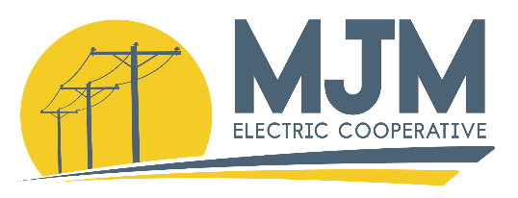
A Touchstone Energy® Cooperative

18300 Shipman Rd • P.O. Box 80 • Carlinville, IL 62626-0080
Office: 217-707-6156 • Fax: 217-854-3918 • Toll Free: 800-648-4729 • www.mjmec.coop
Application for Donation for Organization/Group
Complete the information below. Then, using a separate sheet(s) of paper, answer the questions that follow. Please type or print clearly with dark ink. It is extremely important that you complete the entire application. Incomplete applications will not be considered for funding.
Name of Organization:___________________________________________________________

Address:______________________________________________________________________
Street or Post Office Box
______________________________________________________________________
City State Zip Code

Contact Phone Number(s):________________________________________________________

Contact Person:_________________________________________________________________
Name Title
Email Address:_________________________________________________________________

Is organization requesting funding tax exempt under IRS section 501(c)(3): Yes ___ No ___
- A United States Treasury Department tax exemption letter stating the above-named organization is tax exempt under section 501 (c)(3) and 170 of the Internal Revenue Code must be attached to be eligible for a grant. Letter must be from the IRS Department of the Treasury.

Request:
Project Name:
Amount of Request: $
Total Amount needed for project: $

Please answer the following questions concerning the nature of the request and contributions using a separate sheet(s) of paper:
Nature of Request:
- Describe the project in detail and explain exactly how the funds will be used.
- Explain the circumstances that have prompted this request.
- How does this project meet the Operation Round Up program’s primary objective of community betterment?
- List any other sources of funding for this request.
- Provide the name, address, and phone number of three business references familiar with your organization. References may not be employees or members of the organization requesting funding.

Contributions
Is your organization contributing to the project in terms of cash and/or in-kind/non-cash? If so, provide the details of the contribution. Please attach any appropriate bids/estimates/bills directly relating to your request – this will make the application stronger.

The Grant Review Committee may, from time to time, need to table an application until the next scheduled meeting because of time constraints or insufficient information on an application.
Can your application be tabled? □ Yes □ No
Will you accept partial funding? □ Yes □ No

Comments:_____________________________________________________________________________________________________________________________________________________________________________________________________________________________________________________________________________________________________________
The information contained in this statement is for the purpose of obtaining funding from the M.J.M. Electric Cooperative Operation Round Up Program on behalf of the undersigned. The undersigned understands that the information provided herein is used in deciding to grant funding, and the undersigned represents and warrants that the information provided is true and complete and that the Grant Review Committee may consider this statement as continuing to be true and correct until a written notice of a change is provided. The Grant Review Committee is authorized to make all inquiries it deems necessary to verify the accuracy of the statements made herein.

____________________________________
Name of Organization
____________________________________
Signature of Representative
____________________________________
Date

Please mail your completed application and supporting documents to:
M.J.M. Electric Cooperative
Attn: Brooke Gross
P.O. Box 80
Carlinville, IL 62626

